Nmap -sC <IP>

**3.111.176.77**

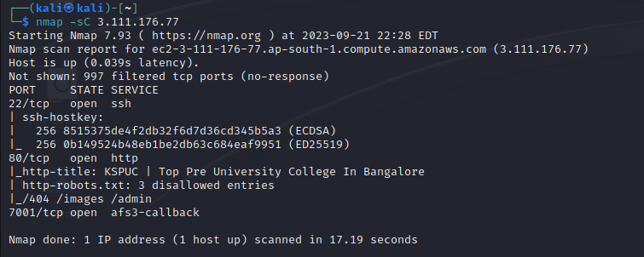

[**13.234.199.150**](https://www.shodan.io/host/13.234.199.150)

Nmap -sC <IP>

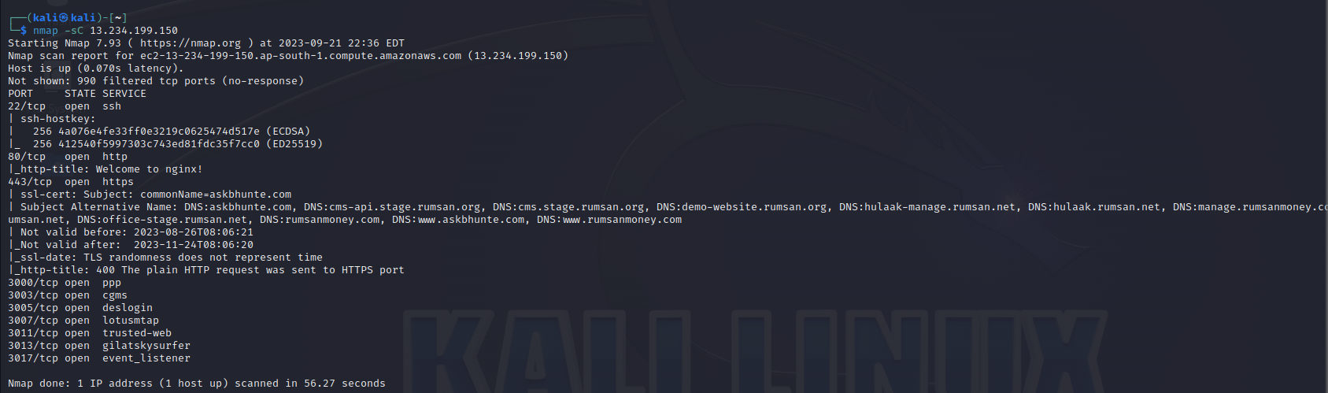

nmap -sV --script=vuln <IP>

[**13.235.26.10**](https://www.shodan.io/host/13.235.26.10)

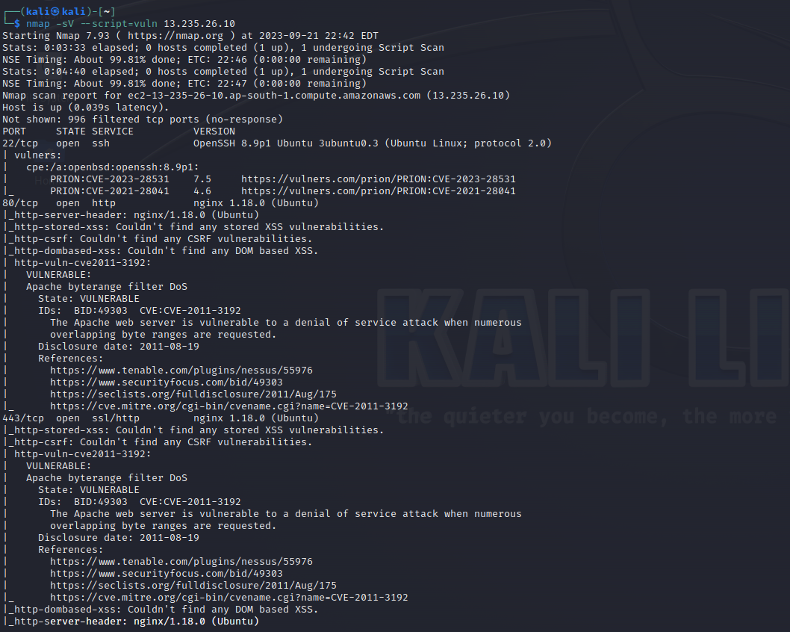

nmap -sV --script=vuln -Pn --vv

[**13.235.26.10**](https://www.shodan.io/host/13.235.26.10)

